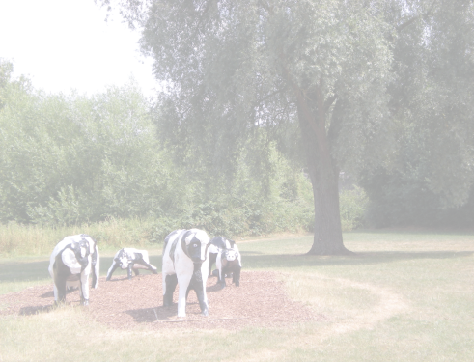
MILTON KEYNES
STOMA SUPPORT GROUP
(MKSSG)
Newsletter Number 2
November 2018

Dear members
Is it really that time of year again already? We really hope you can set aside a couple of hours from all those Christmas preparations to come along to our next quarterly meeting on Saturday December 1st. It will take place between 2.00pm and 4.00pm and will again be at Lovat Fields Village, Japonica Lane, Willen, Milton Keynes, MK15 9LE. Enter the building by the main entrance. We are aiming to have someone on the door to greet you but if you get lost or have difficulty getting in please call us on 07843 768386.
With us for this meeting is Lynn Maddocks from The Parks Trust, who will talk about the work of the Trust. The work is not just about keeping our parks and green spaces looking nice – it is involved in much more besides, and almost certainly in places near or familiar to you. Now is your chance to find out.
In addition three suppliers will be displaying their products – Salts, Bullens and Pelican Healthcare – and there will be special seasonal refreshments available. As usual we will be holding a raffle, and in keeping with the time of year the raffle theme is ‘December delights’. If you can, please bring a raffle prize along with you.
Please continue to bring unwanted in-date supplies to the meeting and give them to Lynne who will make sure they are put to good use.
As most of you know, we meet informally over tea/coffee at Dobbies Garden Centre, Bletchley, on the third Monday of each month, from 10.30ish until lunchtime. Our next get-togethers are on Monday, 17 December, Monday 21 January and 18 February. Please join us any time you can. These informal get-togethers are always great fun even though we can sometimes chat about quite serious matters. Look out for Barnaby, our teddy bear, who sits on our table.
We have attached a full list of meeting dates for 2019 and we hope you will get them in your diaries as soon as possible and join us as often as you can.
We have some sad news to report about two of our members. Enid Owain-Jones sadly passed away recently. She was a delightful lady who even into her nineties lived independently, joined in the social events in her village and came to our meetings right up to June this year. We will miss her greatly. Our other member who has also passed away is Dee Stobie's husband Lionel. They have been strong supporters of the group and in fact Dee did take over the chair for a short period. We send our thoughts and condolences to Dee.
On a happier front, we are very pleased to say that one of our members has had a successful reversal. Wonderful news!'
We hope to see as many of you as possible at the meeting on December 1st as it is the lively chat among members which is the real key to making the afternoon a success.

Best wishes

MKSSG Committee
Contact details: Morag Harvey, mkssg.sec@gmail.com or 07843 768386

